CLASS: A class is a template from which objects are created.

ATTRIBUTE: An attribute is an information that is pertinent to their instances.

OPERATION: An operation is the functionality that the object supports.

The following table represents the class, their attributes and operations of our project:

|  |  |  |
| --- | --- | --- |
| CLASS | Attributes | Methods |
| Admin | Admin_info | Addcompany()  Removecompany()  Loginapproval() |
| Company | Company_name  Company_address  Company_contactno | Companylogin()  Reviewcustomdesign()  Productdetails() |
| Local Buyer | Localbuyer_name  Localbuyer_address  Localbuyer_contactno | Login()  Addlocalbuyer()  Deletelocalbuyer() |
| International Buyer | Foreignbuyer_name  Foreignbuyer_country  Foreignbuyer_address  Foreignbuyer_contactno | Login()  Addforeignbuyer()  Deleteforeignbuyer() |
| Registration | Reg_username  Reg_password  Reg_address  Reg_contactno  Reg_name  Reg_country | Createaccount(), Loginaccount(),  Deleteaccount() |
| Product | Product_name  Product_type  Product_info | Findproduct()  Searchproduct() |
| Product Details | Productdetails_material  Productdetails_production  Productdetails_longivity | Showproductdetail()  Provideproductdetail() |
| Custom Design | Customdesign_upload  Customdesign_select  Customdesign_download | Selectdesign()  Uploaddesign()  Viewdesign() |
| Estimated Price | Price_info | Addprice()  Changeprice()  Removeprice()  Viewprice()  Selectprice() |
| Order Product | Order_write | Addorder()  Changeorder()  Removeorder()  Vieworder() |

Relationship:

Relationships are the connections between classes, similar to those found on an entity-relationship diagram. Relationships are shown as lines connecting classes on a class diagram.

1. Association:

The simplest type of relationship is an association or a structural connection between classes. The end point of the line are labelled with a symbol indicating the multiplicity. Associations are usually labelled with a descriptive name.

The following is the relationship of different classes of our project:

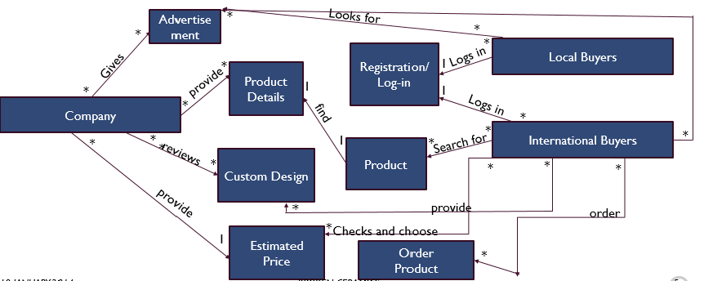

1. Generalization:

A generalization describes a relationship between a general kind of thing and a more specific kind of thing, The general class is also called superclass/ base class and the specialized class is also called subclass/ child class.

The generalization diagram of our project is shown below-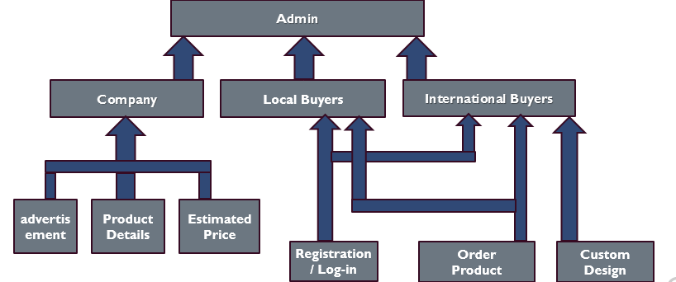

1. Dependency:

Dependency is a weaker form of bond which indicates that one class depends on another class because it uses it at some point in time.

Let us have a look at the dependencies of classes in our project:

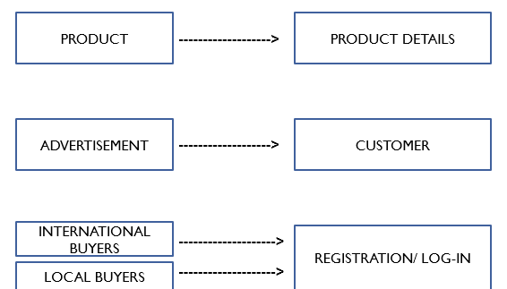

1. Realization:

In UML modeling, a realization relationship is a relationship between two model elements, in which one model element realizes the behavior that the other model element specifies.

Let us have a look at the realizations of classes in our project:

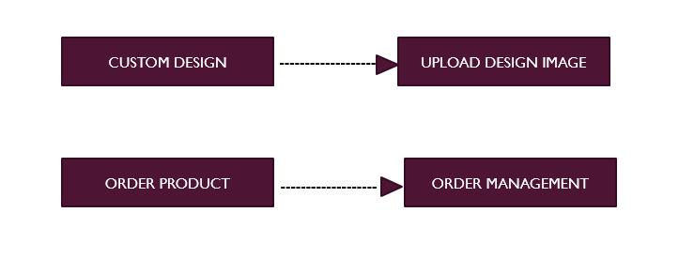

Constraint rules and notes:

* Constraint is a condition or restriction expressed in natural language text or in a machine readable language for the purpose of declaring some of the semantics of an element.
* A note gives the ability to attach various remarks to elements. A note carries no schematic force, but may contain information that is useful to a modeler.

Some constraints of our project is shown as follows:

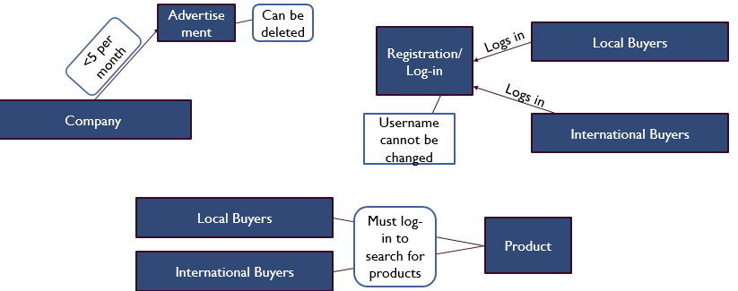

References:

* SYSTEM ANALYSIS AND DESIGN

- KENDALL & KENDALL

* www.visual-paradigm.com/ VPGallery/diagrams/Class.html
* www.cs.unc.edu
* Stackoverflow.com/questions/17860182
* https://en.wikipedia.org/wiki/Class_diagram
* http://www.agilemodeling.com/style/classDiagram.html